# Expressional diversity of grapevine 3-Hydroxy-3-methylglutaryl-CoA reductase (*VvHMGR*) in different grapes genotypes

**Ting Zheng1, Lubin Guan1, Kun Yu2, Muhammad Salman Haider 1, Maazullah Nasim1, Zhongjie Liu1, Teng Li1, Kekun Zhang3, Songtao Jiu4, Haifeng Jia1*and Jinggui Fang1\***

1 College of Horticulture, Nanjing Agricultural University, Nanjing City 210095, Jiangsu Province, PR China

2 College of Agriculture，Shihezi University，Shihezi City 832003，PR China

3 College of Enology, Northwest A&F University, Yangling 712100, PR China

4 Department of Plant Science, Shanghai Jiao Tong University, Shanghai City 200030, Shanghai, PR China

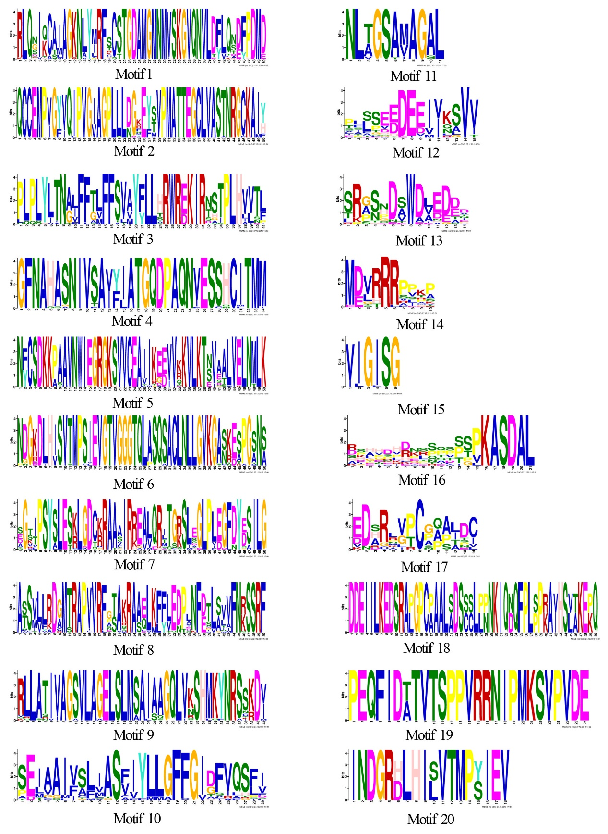

Fig. S1: The amino acid sequence of HMGRs motifs in MEME analysis.

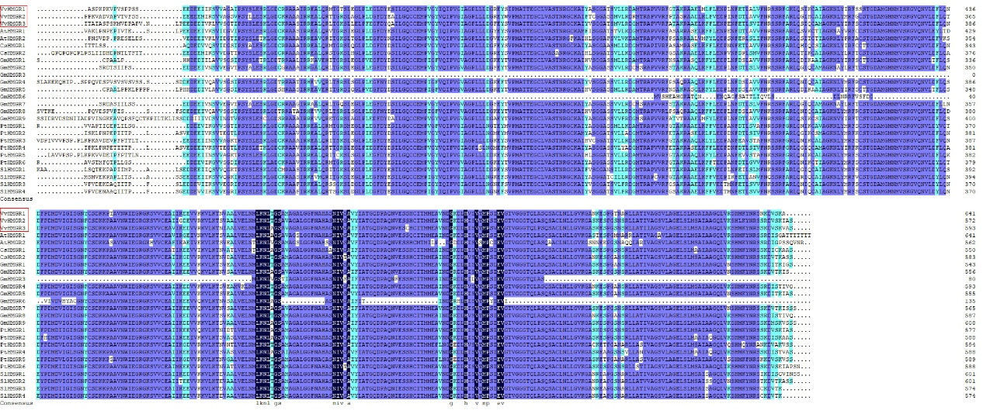

Fig. S2: The multiple alignments of deduced amino acid sequences of HMGRs.

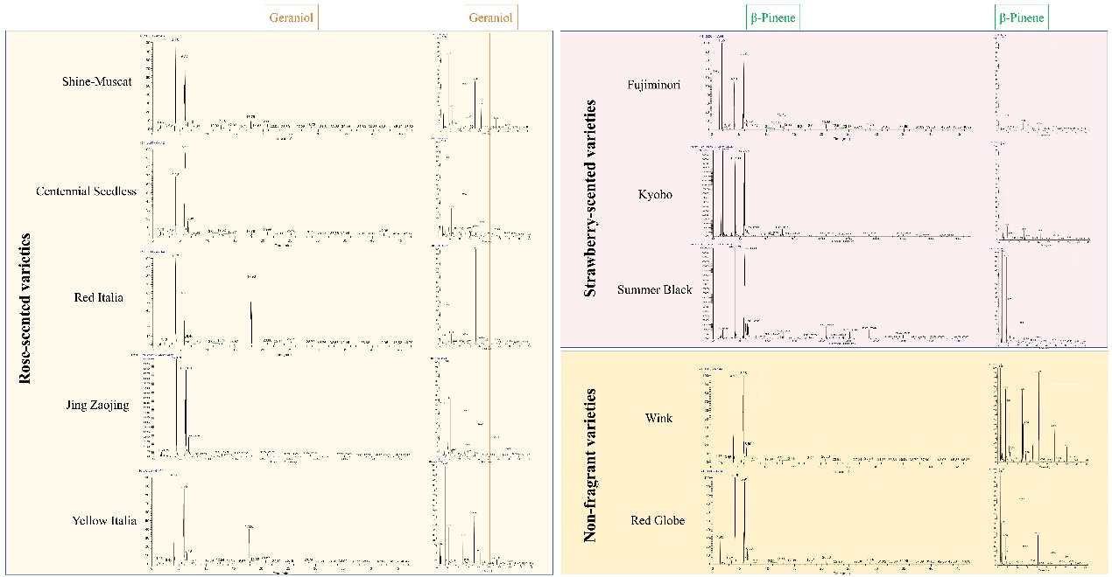

Fig. S3 Aroma components of 10 varieties in berry skin and berry flesh.

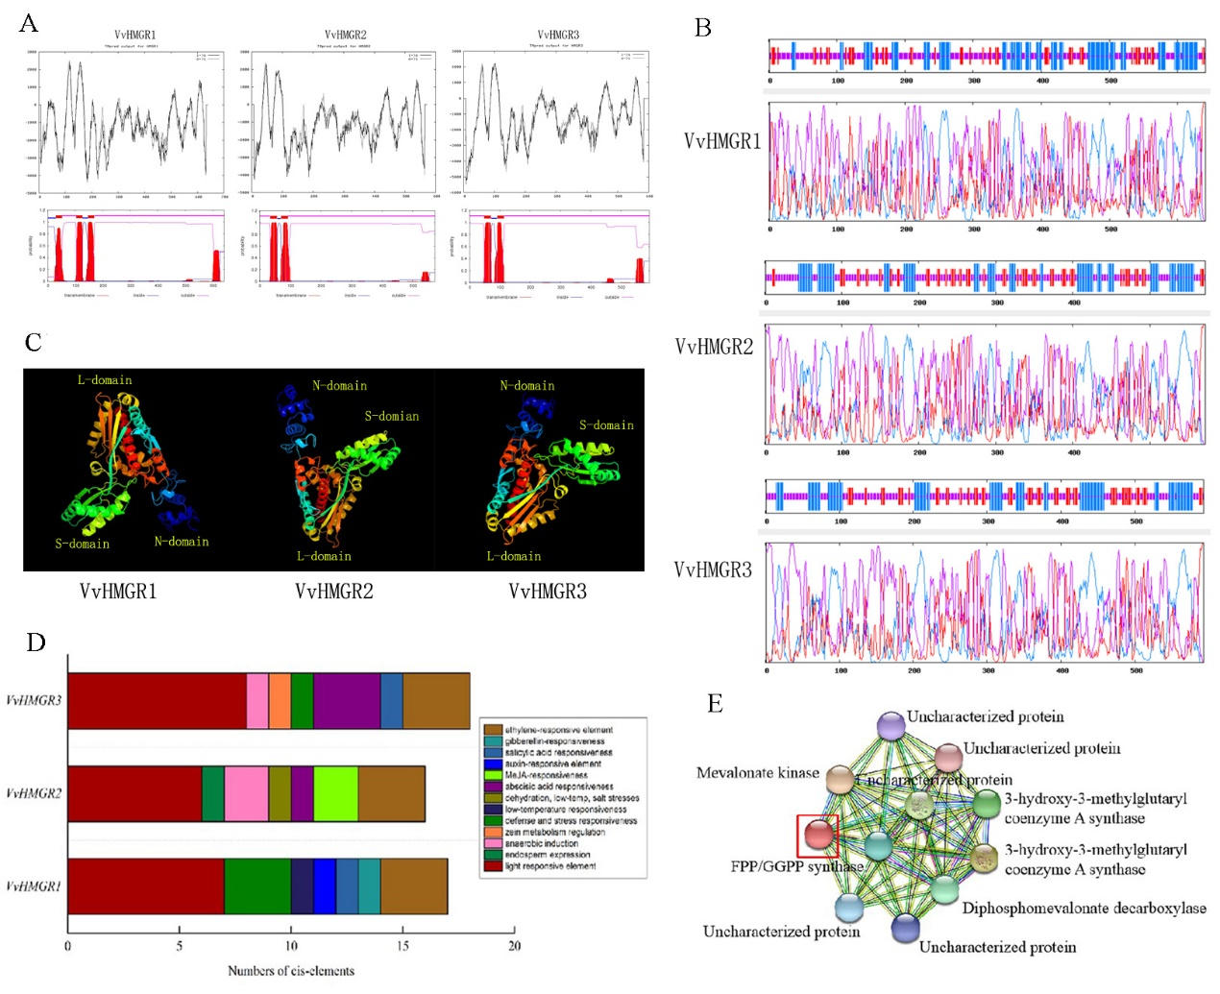

Fig. S4Protein structure and function analysis of VvHMGRs. A. Transmembrane domain prediction and analysis of VvHMGRs protein; B. Secondary structure prediction of VvHMGRs protein; C. Tertiary structure prediction of VvHMGRs protein; D. Promoter cis-acting element analysis; E. Prediction of interaction protein network.

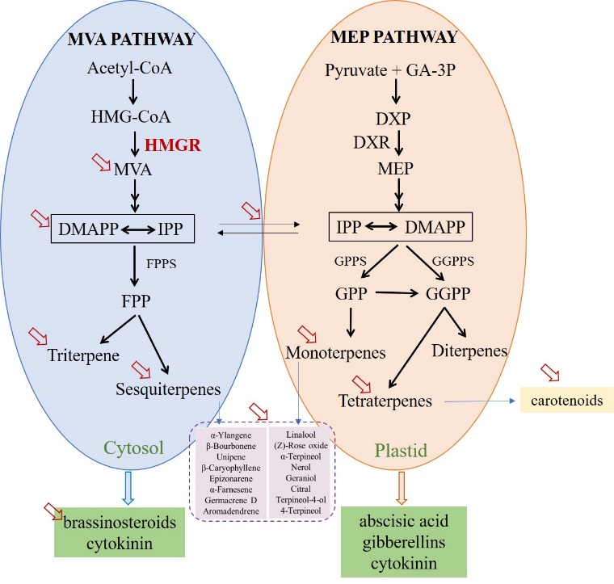

Fig. S5 Synthetic pathways of main terpenoids in grapes. The arrow represents the research results of HMGR affecting the synthesis of terpenoids.